**PROJECT PROFILE**

**1. Project Profile**

**Overview:-**

The project named as “Online Exam” is the web Application or Desktop Application. ONLINE EXAM provides the exam for the General Knowledge Exam.

The main Purpose of the to make this Application is to save the time and there is no need for to strength for the Examination. Online Examination is a Modification System for the Manually Examination. An Exam use held manually but, it use not Expensive for time saving. The new “online examination” is better than Manually Examination.

**Need for the System:-**

1. He wants to know the Rules and Regulation for the examination.
2. He wants to know the Guideline for the examination.
3. He wants to know the result of the current exam on the spot.
4. He also wants to start his pending exam.

**System Definition:-**

***PURPOSE:-***

Online Exam is more compactable then another examination. Online Examination System is less expensive. it require less staff saving the time of student. Quickly check the answers and declare the result at a time. In competitive exam Objective question are pointed. So on time Examination is more useful for such help of System.

***SYSTEM:-***

This system is developed for betterment of students as well as distance learning student. Through which one can appear their Examination in their convenient times.

**Feasibility Study:-**

Feasibility study is the study of the system to check whether the system made is feasible or not. It is very Useful to check whether the system work as per the requirement or not. It is undertaken to determine the possibility of the probability of developing completely new system.

**Need of the feasibility study**

* Answer the question whether the new system is to be developed or Not?
* Define the problem and objectives involved.
* Is the cost incurred in the development of the system of the Justified?

**Operational feasibility: -**

It covers mainly two aspects. It determines that how the proposed system will fit in the current operation and what if the job retraining and restructuring may be needed at the end of the implementation of the system. The operational feasibility checks whether user who is going to use the system as able to work with the software with which the system is coded!

In the system Operation feasibility following are the question to be asked!

Is there sufficient support for the project?

Is current method are acceptable to the user?

Have the user been involved in the planning and development of the System?

System is very user-friendly.

Level of security and any other access control constrains are high.

**Technical feasibility: -**

It determines that work for the project is done with the present equipments and existing software technology.

Necessary all things is easily feasible for the project. Necessary technology, documents, reports are also available. Technical guarantee of accuracy, reliability and security are also provided.

It asks following question?

Does necessary technology exists to do what is suggested?

Do the Proposed equipments have the technical capacity to hold the data required to use new system?

Are there technical guarantees of accuracy, reliability ease of access and data security?

**Economical feasibility: -**

It looks the financial aspects of the project. Economic feasibility concerns with the returns of the investments in the project. It determines whether it is worthwhile to invest money in the proposed system?

**It asks for the following question.**

What is the cost to conduct a full system investigation?

What is the cost of hardware and software required in the development of the proposed system?

Estimated cost is fitted in budget. (I.e. cost of software and hardware is feasible to common person.)

**SOFTWARE**

**&**

**HARDWARE REQUIREMENT**

**2. Software and Hardware Requirement**

### Environment Characteristic:

### Hardware Requirement:

* CPU : Pentium Processor
* Hard Disk : 40 GB or above
* RAM : 512 MB or above
* VDU : SVGA(800*600 pixels)
* Keyboard : 104 IBM
* Operating System : Windows 2000/XP

### Software Requirements:

* SQL Server 2005
* Microsoft visual studio 2008

### Peripherals:

No requirements of any external peripherals.

### Interfaces:

### Interface with device:

* No requirements of any interface with device.

### Interface with O.S.:

* Windows XP-2.

### Interface with Database:

* SQL Server 2005(Express)

### Interface with User:

* Administrator

**SYSTEM ANALYSIS**

**3. System Analysis**

**Problem Definition:-**

Analysis of the system is the process of gathering facts, solutions of problems and to decide overall constitution of the desire system. In system analysis, we have to analysis all the processes, related feature; require features available sources and the time, which should be specified for the analysis stage.

The most important phase of developing any system is system analysis. Because of the analysis phase decide that what type of requirement, materials, strategy, techniques and module are required.

All these things are depend upon our system that what type of outputs of our system or functions, we desire from the system is also responsible for defining the above factors. So overall structure of the system that we want to implement will be decide in analysis of a system development by analyst.

# Risk Analysis

**Risk Identification:-**

Each and every software project is developed under the shadow of risk. All software development groups have three prime concerns with risk.

* + - * 1. Future -> what risk might cause the software project to go away?
        2. Change concern-> how will change in requirement and development in technologies will occur. This was of particular concern to us, since the project we had chosen was an ongoing one, and so there was every leading to change in the software.
        3. Choice -> what methods and tools should be used. How to distribute the work, what level of emphasis is to be given on quality.

There are two types of risks, Proactive and Reactive risks. A reactive risk strategy is nothing but never worrying about problems until they happen. Considerably and impact are assessed, and they are monitored as per their importance. Then the software team establishes a plan for managing risk. The primary objectives are to avoid risk.

We have divided the risks into following categories:-

1. Product size Risks
2. Business Impact Risks
3. Technology Risks
4. Development Environment Risks
5. risks Concerned with Experience
6. **Product Size Risks:-**

We identify the following risks as a major threat to our application. The product would finally be implemented throughout the organization, will include all it’s accounts. Number of projected changes before and after delivery

1. **Business Impact Risks:-**

Business considerations many times conflict with technical considerations. We identified the following as business risks that many fall to our steps during the course of the development of our application.

* What will this product return to the company in terms of revenue?
* Reasonableness of Delivery deadline
* Number of customers using this product and their technical skills
* Amount and quality of documentation to be produced with this product

1. **Technology Risks:-**

Pushing the limits of technology is challenging and exciting. Every technician wishes to use his/her skills to the fullest. But then Murphy’s Law always holds up. The Technical risks that we identified are

* + Environment would be quite different then our previous projects
  + Requirement may demand the creation of program components that are completely new as far as we and the organization is concerned.

1. **Development Environment Risks:-**

Inappropriate and Insufficient tools never lead to an excellent product. Thus development environment has a very big impact on quality and timeliness of the final product. Some of the Development risks identified by us are enlisted below

* + Availability of proper tools for analysis and design
  + Availability of local experts
  + How much is online help and documentation available for the tools?

1. **Risks Concerned with Experience:-**

Inexperience was the major risk associated with our project. Since we lack experienced we were prone to make errors in estimation, design and even identifying the probable risks.

**Plan to Tackle Risks**

Basically we tried to tackle risk in very proactive manner. We identified all the risk that we could foresee and developed an active plan to deal with them.

As far as the project size is concerned we met some experienced staff of the organization and made sure that we are neither overestimating nor underestimating the project. Similar steps for Business and Technical risks were taken.

Development Environment risks was taken care of by the organization themselves. They are making sure that we get whatever tools required for developing a good quality product. Also concerned help from whatever help from experts is being arranged.

# Process Model

**Spiral Model**

**DEFINITION** - The spiral model, also known as the spiral lifecycle model, is a systems development method (SDM) used in information technology (IT). This model of development combines the features of the prototyping model and the [waterfall model](http://en.wikipedia.org/wiki/Waterfall_model). The spiral model is intended for large, expensive, and complicated projects.

[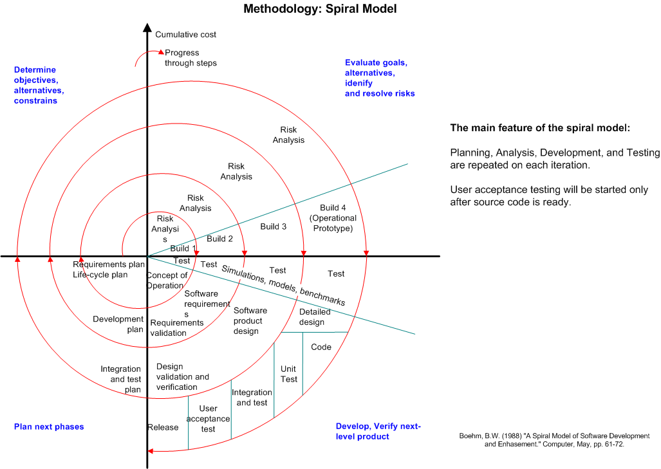](http://myprojects.kostigoff.net/methodology/development_models/development_models.htm#spiral)

The steps in the spiral model can be generalized as follows:

1. A preliminary design is created for the new system.
2. A first [prototype](http://en.wikipedia.org/wiki/Prototype) of the new system is constructed from the preliminary design. This is usually a scaled-down system, and represents an approximation of the characteristics of the final product.
3. A second prototype is evolved by a fourfold procedure:

(I) evaluating the first prototype in terms of its strengths, weaknesses,

And risks;

(ii) Defining the requirements of the second prototype;

(iii) Planning and designing the second prototype;

(iv) Constructing and testing the second prototype.

1. At the customer's option, the entire project can be aborted if the risk is deemed too great. Risk factors might involve development cost overruns, operating-cost miscalculation, or any other factor that could, in the customer's judgment, result in a less-than-satisfactory final product.
2. The existing prototype is evaluated in the same manner as was the previous prototype, and, if necessary, another prototype is developed from it according to the fourfold procedure outlined above.
3. The preceding steps are iterated until the customer is satisfied that the refined prototype represents the final product desired.
4. The final system is constructed, based on the refined prototype.
5. The final system is thoroughly evaluated and tested. Routine maintenance is carried out on a continuing basis to prevent large-scale failures and to minimize downtime.

## Advantages

* Estimates (i.e. budget, schedule, etc.) get more realistic as work progresses, because important issues are discovered earlier.
* It is more able to cope with the (nearly inevitable) changes that software development generally entails.
* Software engineers (who can get restless with protracted design processes) can get their hands in and start working on a project earlier.

**SYSTEM DESIGN**

**4. System Design**

**5.1) Data Dictionary**

|  |
| --- |
|  |
|  |

In database management system a [file](http://www.webopedia.com/TERM/D/file.html) that defines the basic organization of a [database](http://www.webopedia.com/TERM/D/database.html). A data dictionary contains a list of all files in the database, the number of [records](http://www.webopedia.com/TERM/D/record.html) in each file, and the [names](http://www.webopedia.com/TERM/D/name.html) and types of each [field](http://www.webopedia.com/TERM/D/field.html). Most [database management systems](http://www.webopedia.com/TERM/D/data_dictionary.html##) keep the data dictionary hidden from [users](http://www.webopedia.com/TERM/D/user.html) to prevent them from accidentally destroying its contents.

Data dictionaries do not contain any actual [data](http://www.webopedia.com/TERM/D/data.html) from the database, only book keeping information for managing it. Without a data dictionary, however, a database management system cannot [access](http://www.webopedia.com/TERM/D/access.html) data from the database

Questions database table

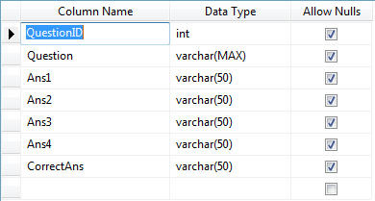

Answer View

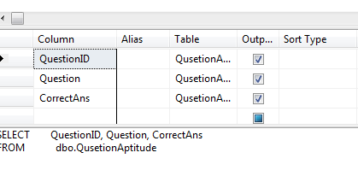

**UML DIAGRAM**

**1. USE CASE DIAGRAM**



**2. Activity Diagram**



**3. Class Diagram**



**SCREEN LAYOUT**

**Website Home Page:-**

**Form Name: - Home.aspx**

**Address: -** 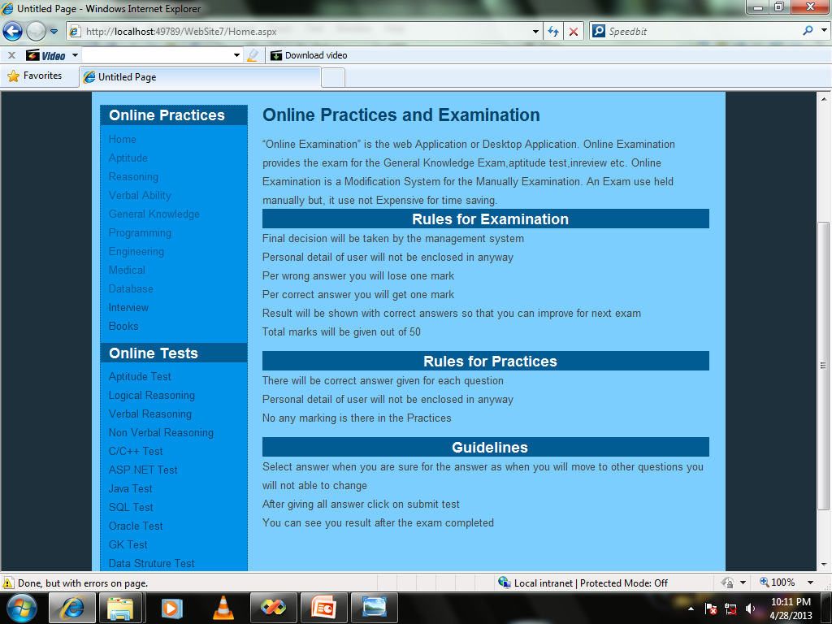

**Description:-**

**This is our Website Home Page. There are links like home, Guidelines, Rules &Regulation, Book, Question, etc.**

**Website Practices for Arithmetic**

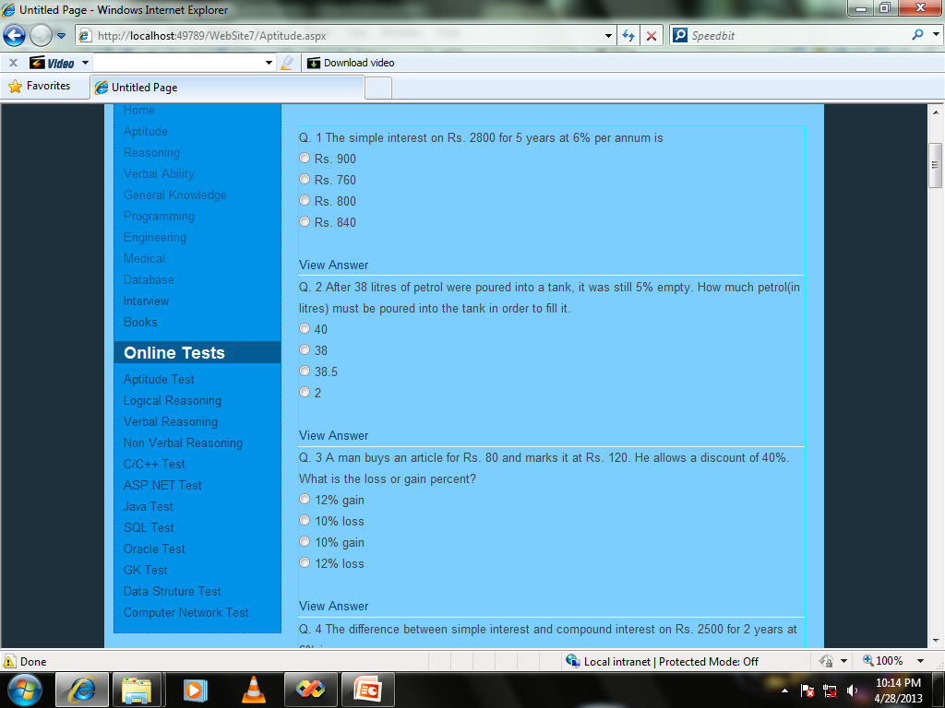

**Description:-**

**This is our Arithmetic Part problems. This Page Contains Questions of Arithmetic.**

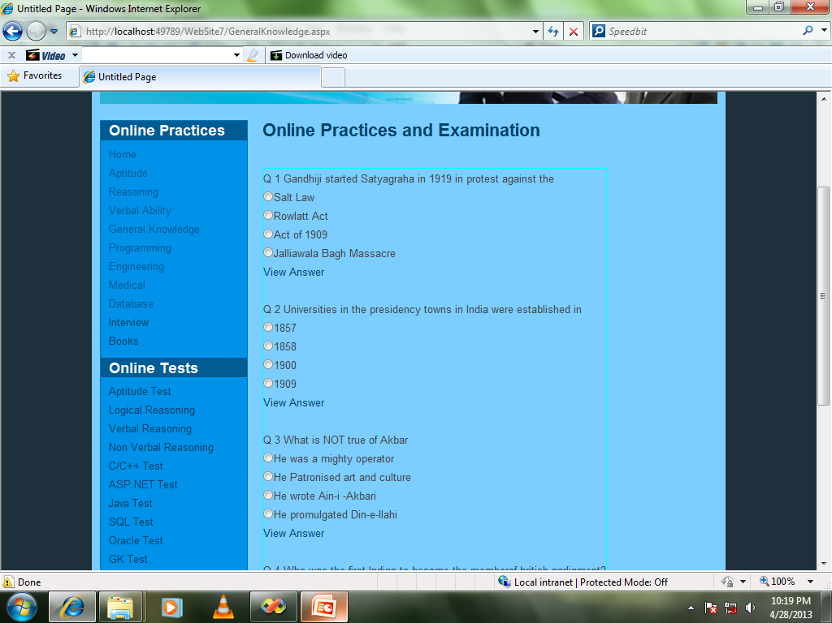

**Description:-**

**This is history based Questions.**

**Website Book Page:-**

**Form Name: - Book.aspx**

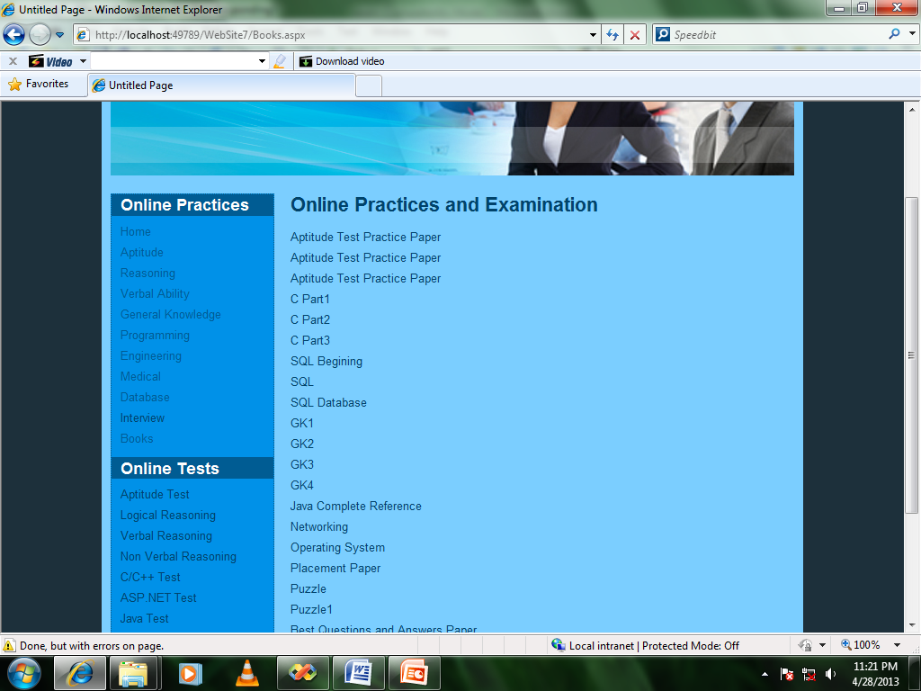

**Description:-**

**This is our Website Book Page. User can show the Book for the Exam from this page.**

PROJECT SCHEDULING

|  |  |  |  |  |
| --- | --- | --- | --- | --- |
| **No.** | **Task Name** | **Start Date** | **End Date** | **Time Duration** |
| 1. | Fact Finding and  Requirement | 28-01-2013 | 3-02-2013 | 6 |
| 2. | System Requirement | 4-02-2013 | 11-02-2013 | 8 |
| 3. | System Design | 12-02-2013 | 13-03-2013 | 31 |
| 4. | System Coding | 14-03-2013 | 3-05-2013 | 49 |
| 5. | System Testing | 04-05-2013 | 10-05-2013 | 6 |
| 6. | System Implementation and maintenance | 11-05-2013 | 14-05-2013 | 4 |

**5. Project scheduling**

**SYSTEM TESTING**

**6. System Testing**

**TESTING PLAN**

When a system is developed, it is hoped that it performs properly. In practice, however, some errors always occur. The main purpose of testing a system is to find the errors and correct them. A successful test is one that finds an error. The main objectives of system testing are:

* To ensure that during operation the system will perform as per specifications.
* To make sure that the system meets user’s requirements during operation.
* To verify that the controls incorporated in the system function as intended.
* To see that when correct inputs are fed to the system outputs ate correct.
* To make sure that during operations, incorrect input, processing and output will be detected.

**Quality Assurance:-**

The amount and complexity of S/W produced today stagger the imagination. s/w development strategies have not kept pace, however and s/w products fall short of meeting application objectives. Consequently controls must be developed to ensure a quality product. Basically, quality assurance defines the objectives of the project and reviews the overall activities so that errors are corrected early in the development process.

The goals and their relevance to the quality assurance of the system are as follows:

**Quality factor specification**

The goal of this stage is to define the factors that contribute the quality of candidate system.

Several factors determine the quality of the system.

* Correctness
* Reliability
* Efficiency
* Usability
* Maintainability
* Testability
* Portability
* Accuracy
* Error tolerance
* Expandability
* Access control
* Communication

**Software requirements specifications**

# The quality assurance goal of this stage is to generate the requirements document that provides this technical specification for the design and development of the s/w.

**Software Design Specifications**

In the stage, the s/w design document defines the overall architecture of this function and features described in the s/w that provides the function and feature describes in the s/w requirement document.

**Software Testing and Implementation**

The quality assurance goal of the testing phase is ensure that completeness and accuracy of the system and minimize the resulting process. In the implementation phase, the goal is to provide a logical order for the creation of the modules and in turn, the creation of the system.

**Maintenance and Support**

This phase provides the necessary s/w adjustment for the system to continue to comply with the original specifications. The quality assurance goal is to develop a procedure for correcting errors and enhancing s/w.

**TESTING STRATEGY**

* **Black box testing**

The functionality of the application was tested with the requirement specification. This was done to ensure that the functionality expected was captures as per the requirement specification.

This testing is also known as functional testing. Black box testing is a s/w testing technics whereby the internal functionality of the item being tested I not known to tester. For example, in a black box test on s/w design, the tester only knows the inputs, what the expected outcomes are, and not the program arrives at those outputs. The tester doses not ever examine the programming code and doses not need any further knowledge of the program other than its specification.

* **White box testing**

This is basically sone to ensure that the logic applied is correct and to check where the code fails. This is done knowing the logical flow of the functionality and implementation. White box testing is used because:

* Logic error and correct assumption are most likely to be made when coding “ SPECIAL CASES”. Need to ensure that these execution paths to be incorrect and so make design error. White box can pick these errors out.
* **Unit testing**

Since the system is made by dividing it in modules, all the modules play an important role in the system so each unit had to be individually tested. The development was done in interaction and after each iteration was completed, test cases were prepared and all the features tested. During developers test their own code. When the test is passed, they are moved over for integration testing. Testing was done to ensure both the functionality and the security aspects of the system. The test cases designed must involve the execution of the operation with different user roles and privileges.

* **Integration testing**

After testing the individual units the package as a whole has been tested. Thus, we follow the “BOTTOM UP APPROACH” for the testing. All the modules were tested separately also and together also for both, the performance and the output accuracy.

**TESTING METHODS**

* **Alpha and Beta testing**
* It is virtually impossible for a s/w developer to foresee how a customer will really use a program.
* When custom s/w is built for one customer, a series of acceptance tests are conducted to enable the customer to validate all requirements.
* If the s/w is developed as a product to be used by many customer, it is impractical to perform formal acceptance tests with each one. Most s/w professional use a process called alpha and beta testing to uncover the errors that only the end – user seems able to find.
* **ALPHA TESTING**
* The Alpha test is conducted at the developer’s site by s customer. The s/w is used with a developer “LOOKING OVER THE SHOULDER” of a user and recording errors and usage problems
* **BETE TESTING**
* The beta test is conducted as one or more sites by the end user of the s/w. unlike the alpha testing we were not present. Therefore the bete test is a “LIVE” of the application of the s/w in an environment that cannot be controlled by the developer.

**FUTURE ENHANCEMENT**

**7. Future Enhancement**

In our project there is some limitation which may become the subject of future enhancement. In this project we have concentrate on only General Knowledge EXAM as well as many. Future enhancement of this project is to include management of whole all the type of Exam.

**8. Summary**

Working on this project has given us valuable experience. It has been like stepping on the first step of the staircase that leads towards building our career. It was our first experience of working in the atmosphere of a full fledges firm. We were taught the etiquettes that were requiring to be followed in office environment, which would be vary helpful to us for our future endeavours.

At the time of practically executing our knowledge we were fortunate to have very cooperative and supportive project guide and colleagues. Their attitude toward us was very helpful.

Initially, when we stared developing the system and as and when the requirements poured in, It was really exciting for us to know that the things which initially look simple can include so many features, and developing it was a knowledgeable experience for us.

We took this opportunity to convey our special thanks to all those who played role in making this project a success and a great learning experience for us.

Working on this project has given us valuable experience. It has been like stepping on the first step of the staircase that leads towards building our career. It was our first experience of working in the atmosphere of a full fledges firm. We were taught the etiquettes that were requiring to be followed in office environment, which would be vary helpful to us for our future endeavours.

At the time of practically executing our knowledge we were fortunate to have very cooperative and supportive project guide and colleagues. Their attitude toward us was very helpful.

Initially, when we stared developing the system and as and when the requirements poured in, It was really exciting for us to know that the things which initially look simple can include so many features, and developing it was a knowledgeable experience for us.

We took this opportunity to convey our special thanks to all those who played role in making this project a success and a great learning experience for us.

**BIBLIOGRAPHY**

**9. Bibliography**

**BOOKS**

* **“Asp.Net 2.0 Unleashed”**
* Stephen walther
* Sams Publication
* **“SQL, PL/SQL”**
* “Ivan Bay Ross”
* BPB Publication

**LINKS**

* [www.Code4u.com](http://www.Code4u.com)
* [www.codeguru.com](http://www.codeguru.com)
* [www.onlineexam.com](http://www.onlineexam.com)